**Shubhan Singh**

**2022300118**

**SE-Comps B/Batch C**

**15th February 2024**

**Scilab no.3: Row Echelon Form**

**Program No.1** :- Write a Sci-Lab code to convert given matrix to row echelon form:

A = $\left[\begin{aligned}1 2-1 3 \\ 3 -1 2 1 \\ 2 -2 3 2 \\ 1-1 1 -1\end{aligned}\right]$

**Code :-**

clc

A=[1 2 -1 3;3 -1 2 1;2 -2 3 2;1 -1 1 -1];

printf("Original matrix is:");

disp(A);

n=4;

for i=1:n

if A(i,i)==0

A(i,:)=A(i,:)

else

A(i,:)=A(i,:)/A(i,i);

disp(A)

for j=1:n-1

if i+j<n+1

A(i+j,:)=A(i+j,:)-A(i+j,i)*A(i,:)

else

end

end

end

if A(1,2)== A(2,2)

A(1,:)=A(1,:)-A(2,:)

else

end

disp(A)

end

**Output :-**

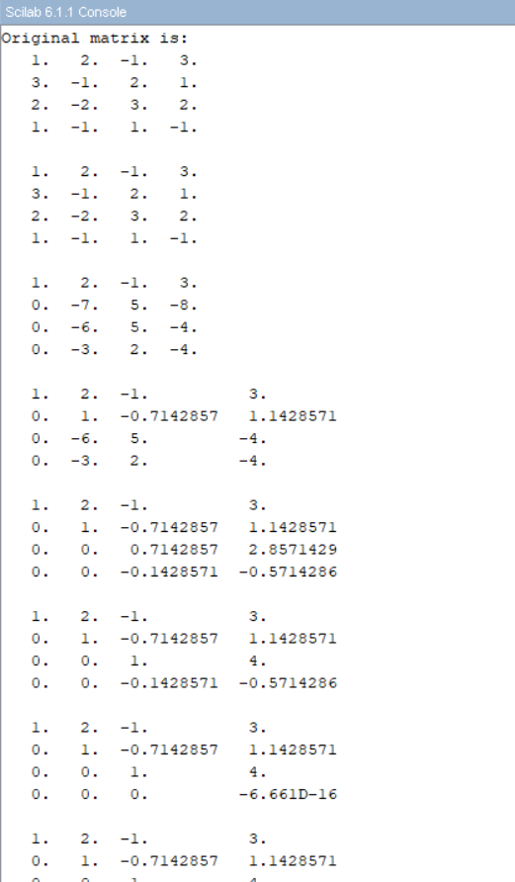

**Program No. 2:-** Write a Sci-Lab code using for loop to convert given matrix to row echelon form:

A = $\left[\begin{matrix}2 & -1 & 3 & 4 \\ 0 & 3 & 4 & 1 \\ 2 & 3 & 7 & 4 \\ 2 & 5 & 11 & 6\end{matrix}\right]$

**Code**:-

clc

A=[2 -1 3 4;0 3 4 1;2 3 7 4;2 5 11 6];

printf("Original matrix is:");

disp(A);

n=4;

for i=1:n

if A(i,i)==0

A(i,:)=A(i,:)

else

A(i,:)=A(i,:)/A(i,i);

disp(A)

for j=1:n-1

if i+j<n+1

A(i+j,:)=A(i+j,:)-A(i+j,i)*A(i,:)

else

end

end

end

if A(1,2)== A(2,2)

A(1,:)=A(1,:)-A(2,:)

else

end

disp(A)

end

**Output** :-

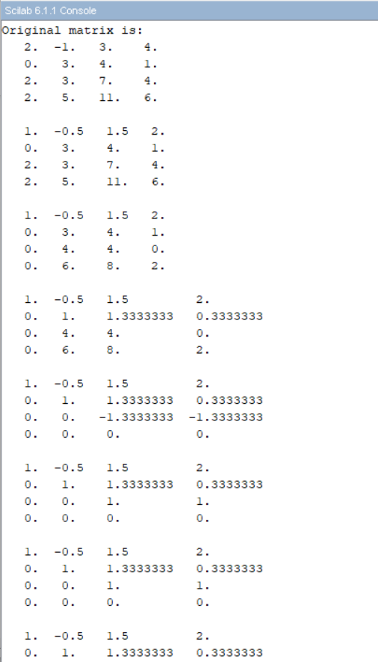

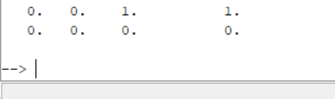

**Program No. 3 :-** Write a Scilab code to convert the given matrix to row echelon form

A = $\left[\begin{matrix}1 & 2 & 3 & -1 \\ -2 & -1 & -3 & -1 \\ 1 & 0 & 1 & 1 \\ 0 & 1 & 1 & -1\end{matrix}\right]$

**Code** :-

clc

A=[1 2 3 -1;-2 -1 -3 -1;1 0 1 1;0 1 1 -1];

printf("Original matrix is:");

disp(A);

n=4;

for i=1:n

if A(i,i)==0

A(i,:)=A(i,:)

else

A(i,:)=A(i,:)/A(i,i);

disp(A)

for j=1:n-1

if i+j<n+1

A(i+j,:)=A(i+j,:)-A(i+j,i)*A(i,:)

else

end

end

end

if A(1,2)== A(2,2)

A(1,:)=A(1,:)-A(2,:)

else

end

disp(A)

end

**Output** :-

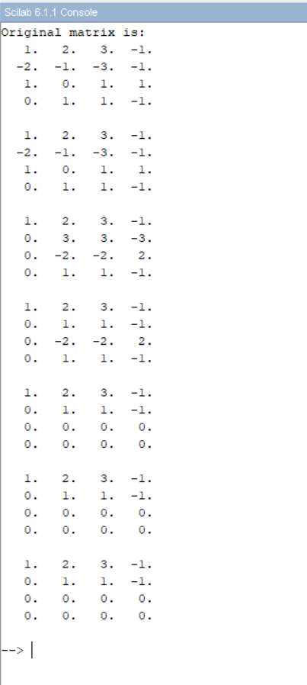

**Program no. 4** :- Write a Scilab code to convert the given matrix to row echelon form

A = $\left[\begin{matrix}1 & 1 & 1 \\ 1 & 2 & 4 \\ 1 & 4 & 10\end{matrix}\right]$

**Code** :-

clc

A=[1 1 1;1 2 4;1 4 10];

printf("Original matrix is:");

disp(A);

n=3;

for i=1:n

if A(i,i)==0

A(i,:)=A(i,:)

else

A(i,:)=A(i,:)/A(i,i);

disp(A)

for j=1:n-1

if i+j<n+1

A(i+j,:)=A(i+j,:)-A(i+j,i)*A(i,:)

else

end

end

end

if A(1,2)== A(2,2)

A(1,:)=A(1,:)-A(2,:)

else

end

disp(A)

end

**Output** :-

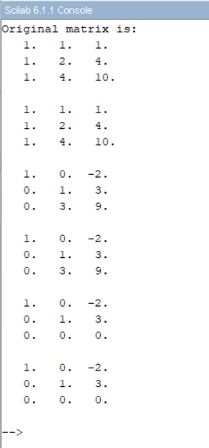

**Program No. 5** :- Write a Scilab code to convert the given matrix to row echelon form

A = $\left[\begin{matrix}1 & 2 & 3 & 4 \\ 2 & 1 & 4 & 5 \\ 8 & 5 & 14 & 17 \\ 1 & 5 & 5 & 7\end{matrix}\right]$

**Code** :-

clc

A=[1 2 3 4;2 1 4 5;8 5 14 17;1 5 5 7];

printf("Original matrix is:");

disp(A);

n=4;

for i=1:n

if A(i,i)==0

A(i,:)=A(i,:)

else

A(i,:)=A(i,:)/A(i,i);

disp(A)

for j=1:n-1

if i+j<n+1

A(i+j,:)=A(i+j,:)-A(i+j,i)*A(i,:)

else

end

end

end

if A(1,2)== A(2,2)

A(1,:)=A(1,:)-A(2,:)

else

end

disp(A)

end

**Output** :-

